**DAYANAND ACADEMY OF MANAGEMENT STUDIES**

**BACHELOR OF COMPUTER APPLICATION**

**BATCH(2023-2026)**

**PROJECT-1**

**TOPIC- DEPLOY A STATIC WEBSITE ON AWS**

**SUBMITTED BY:- SUBMITTED TO:-**

**MAYANK SINGH ABHINAV SIR**

**BCA SEMESTER-2**

**Topics**

* [Step 1: Create a bucket](https://docs.aws.amazon.com/AmazonS3/latest/userguide/HostingWebsiteOnS3Setup.html#step1-create-bucket-config-as-website)
* [Step 2: Enable static website hosting](https://docs.aws.amazon.com/AmazonS3/latest/userguide/HostingWebsiteOnS3Setup.html#step2-create-bucket-config-as-website)
* [Step 3: Edit Block Public Access settings](https://docs.aws.amazon.com/AmazonS3/latest/userguide/HostingWebsiteOnS3Setup.html#step3-edit-block-public-access)
* [Step 4: Add a bucket policy that makes your bucket content publicly available](https://docs.aws.amazon.com/AmazonS3/latest/userguide/HostingWebsiteOnS3Setup.html#step4-add-bucket-policy-make-content-public)
* [Step 5: Configure an index document](https://docs.aws.amazon.com/AmazonS3/latest/userguide/HostingWebsiteOnS3Setup.html#step5-upload-index-doc)
* [Step 6: Configure an error document](https://docs.aws.amazon.com/AmazonS3/latest/userguide/HostingWebsiteOnS3Setup.html#step6-upload-error-doc)
* [Step 7: Test your website endpoint](https://docs.aws.amazon.com/AmazonS3/latest/userguide/HostingWebsiteOnS3Setup.html#step7-test-web-site)
* [Step 8: Clean up](https://docs.aws.amazon.com/AmazonS3/latest/userguide/HostingWebsiteOnS3Setup.html#getting-started-cleanup-s3-website-overview)

**Step 1: Create a bucket**

The following instructions provide an overview of how to create your buckets for website hosting. For detailed, step-by-step instructions on creating a bucket.

**To create a bucket**

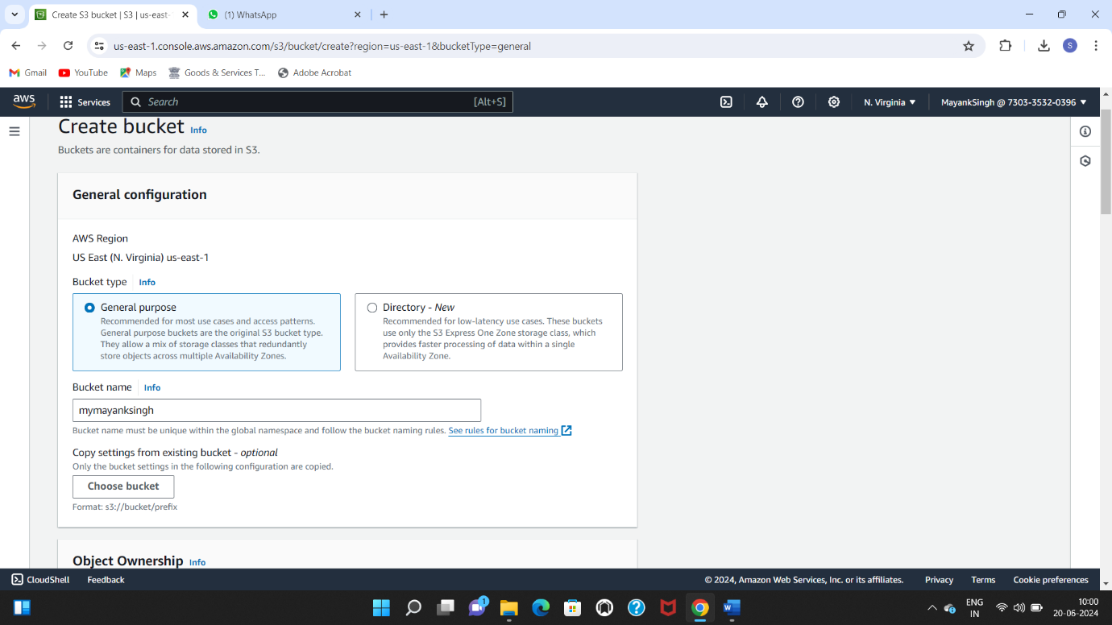

1. Sign in to the AWS Management Console and open the Amazon S3 console at <https://console.aws.amazon.com/s3/>.
2. Choose **Create bucket**.
3. Enter the **Bucket name** (for example, **webbucket**).
4. Choose the Region where you want to create the bucket.

Choose a Region that is geographically close to you to minimize latency and costs, or to address regulatory requirements. The Region that you choose determines your Amazon S3 website endpoint.

1. To accept the default settings and create the bucket, choose **Create**.

**Step 2: Enable static website hosting**

After you create a bucket, you can enable static website hosting for your bucket.

**To enable static website hosting**

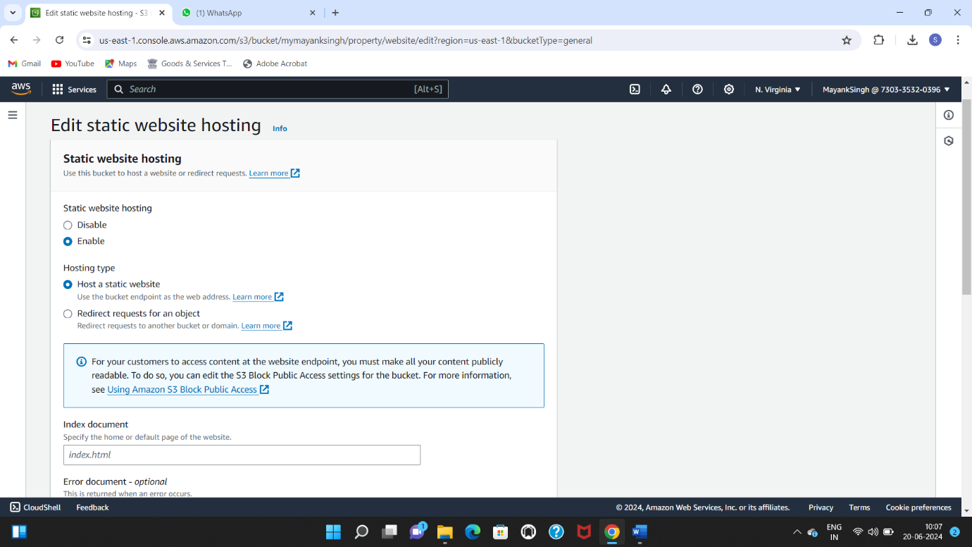

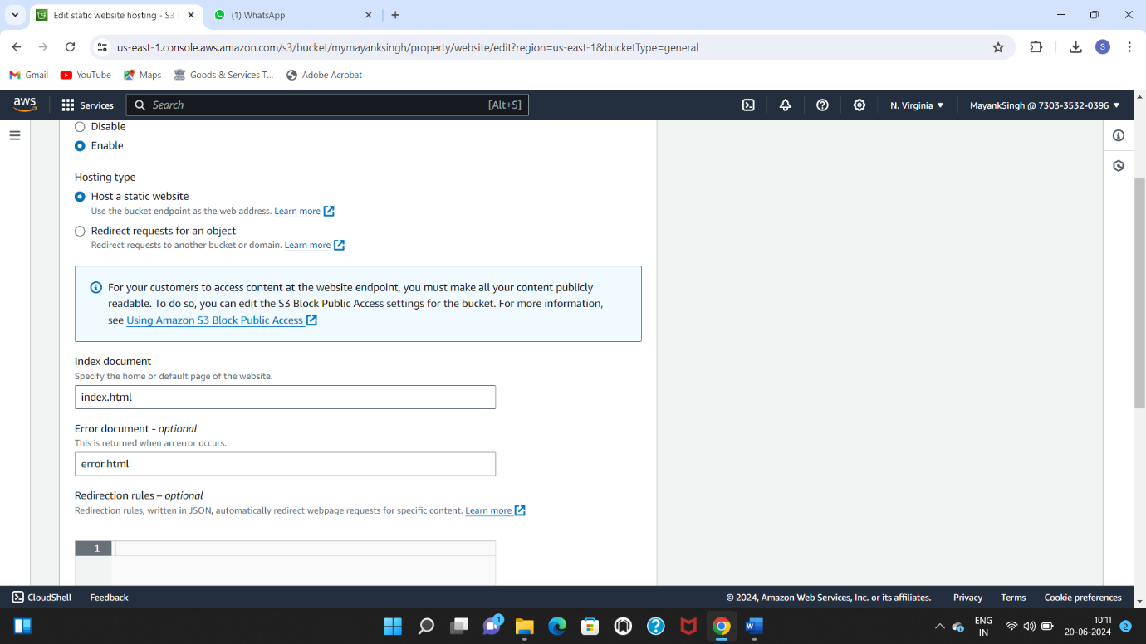

1. Sign in to the AWS Management Console and open the Amazon S3 console at <https://console.aws.amazon.com/s3/>.
2. In the **Buckets** list, choose the name of the bucket that you want to enable static website hosting for.
3. Choose **Properties**.
4. Under **Static website hosting**, choose **Edit**.
5. Choose **Use this bucket to host a website**.
6. Under **Static website hosting**, choose **Enable**.
7. In **Index document**, enter the file name of the index document, typically index.html.

The index document name is case sensitive and must exactly match the file name of the HTML index document that you plan to upload to your S3 bucket. When you configure a bucket for website hosting, you must specify an index document. Amazon S3 returns this index document when requests are made to the root domain or any of the subfolders.

1. (Optional) If you want to specify advanced redirection rules, in **Redirection rules**, enter JSON to describe the rules.

For example, you can conditionally route requests according to specific object key names or prefixes in the request.

1. Choose **Save changes**.

Amazon S3 enables static website hosting for your bucket. At the bottom of the page, under **Static website hosting**, you see the website endpoint for your bucket.

1. Under **Static website hosting**, note the **Endpoint**.

The **Endpoint** is the Amazon S3 website endpoint for your bucket. After you finish configuring your bucket as a static website, you can use this endpoint to test your website.

**Step 3: Edit Block Public Access settings**

By default, Amazon S3 blocks public access to your account and buckets. If you want to use a bucket to host a static website, you can use these steps to edit your block public access settings.

1. Open the Amazon S3 console at <https://console.aws.amazon.com/s3/>.
2. Choose the name of the bucket that you have configured as a static website.
3. Choose **Permissions**.
4. Under **Block public access (bucket settings)**, choose **Edit**.
5. Clear **Block *all* public access**, and choose **Save changes**.

**Warning**

Before you complete this step, review [Blocking public access to your Amazon S3 storage](https://docs.aws.amazon.com/AmazonS3/latest/userguide/access-control-block-public-access.html) to ensure you understand and accept the risks involved with allowing public access. When you turn off block public access settings to make your bucket public, anyone on the internet can access your bucket. We recommend that you block all public access to your buckets.

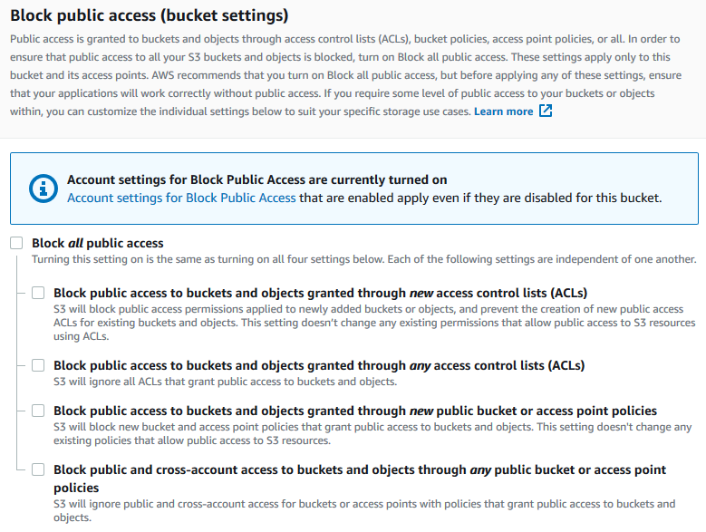

Amazon S3 turns off Block Public Access settings for your bucket. To create a public, static website, you might also have to [edit the Block Public Access settings](https://docs.aws.amazon.com/AmazonS3/latest/user-guide/block-public-access-account.html) for your account before adding a bucket policy.

**Step 4: Add a bucket policy that makes your bucket content publicly available**

After you edit S3 Block Public Access settings, you can add a bucket policy to grant public read access to your bucket. When you grant public read access, anyone on the internet can access your bucket.

**Important**

The following policy is an example only and allows full access to the contents of your bucket.

1. Under **Buckets**, choose the name of your bucket.
2. Choose **Permissions**.
3. Under **Bucket Policy**, choose **Edit**.
4. To grant public read access for your website, copy the following bucket policy, and paste it in the **Bucket policy editor**.
5. {
6. "Version": "2012-10-17",
7. "Statement": [
8. {
9. "Sid": "PublicReadGetObject",
10. "Effect": "Allow",
11. "Principal": "*",
12. "Action": [
13. "s3:GetObject"
14. ],
15. "Resource": [
16. "arn:aws:s3:::*Bucket-Name*/*"
17. ]
18. }
19. ]

}

1. Update the Resource to your bucket name.

In the preceding example bucket policy, *Bucket-Name* is a placeholder for the bucket name. To use this bucket policy with your own bucket, you must update this name to match your bucket name.

1. Choose **Save changes**.

A message appears indicating that the bucket policy has been successfully added.

If you see an error that says Policy has invalid resource, confirm that the bucket name in the bucket policy matches your bucket name.

If you get an error message and cannot save the bucket policy, check your account and bucket Block Public Access settings to confirm that you allow public access to the bucket.

**Step 5: Configure an index document**

When you enable static website hosting for your bucket, you enter the name of the index document (for example, **index.html**). After you enable static website hosting for the bucket, you upload an HTML file with this index document name to your bucket.

**To configure the index document**

1. Create an index.html file.

If you don't have an index.html file, you can use the following HTML to create one:

<html xmlns="http://www.w3.org/1999/xhtml" >

<head>

<title>My Website Home Page</title>

</head>

<body>

<h1>Welcome to my website</h1>

<p>Now hosted on Amazon S3!</p>

</body>

</html>

1. Save the index file locally.

The index document file name must exactly match the index document name that you enter in the **Static website hosting** dialog box. The index document name is case sensitive. For example, if you enter index.html for the **Index document** name in the **Static website hosting** dialog box, your index document file name must also be index.html and not Index.html.

1. Sign in to the AWS Management Console and open the Amazon S3 console at <https://console.aws.amazon.com/s3/>.
2. In the **Buckets** list, choose the name of the bucket that you want to use to host a static website.
3. Enable static website hosting for your bucket, and enter the exact name of your index document (for example, index.html).

After enabling static website hosting, proceed to step 6.

1. To upload the index document to your bucket, do one of the following:
   * Drag and drop the index file into the console bucket listing.
   * Choose **Upload**, and follow the prompts to choose and upload the index file.

1. (Optional) Upload other website content to your bucket.

**Step 6: Configure an error document**

When you enable static website hosting for your bucket, you enter the name of the error document (for example, **404.html**). After you enable static website hosting for the bucket, you upload an HTML file with this error document name to your bucket.

**To configure an error document**

1. Create an error document, for example 404.html.
2. Save the error document file locally.

The error document name is case sensitive and must exactly match the name that you enter when you enable static website hosting. For example, if you enter 404.html for the **Error document** name in the **Static website hosting** dialog box, your error document file name must also be 404.html.

1. Sign in to the AWS Management Console and open the Amazon S3 console at <https://console.aws.amazon.com/s3/>.
2. In the **Buckets** list, choose the name of the bucket that you want to use to host a static website.
3. Enable static website hosting for your bucket, and enter the exact name of your error document (for example, 404.html).

After enabling static website hosting, proceed to step 6.

1. To upload the error document to your bucket, do one of the following:
   * Drag and drop the error document file into the console bucket listing.
   * Choose **Upload**, and follow the prompts to choose and upload the index file.

**Step 7: Test your website endpoint**

After you configure static website hosting for your bucket, you can test your website endpoint.

1. Under **Buckets**, choose the name of your bucket.
2. Choose **Properties**.
3. At the bottom of the page, under **Static website hosting**, choose your **Bucket website endpoint**.

Your index document opens in a separate browser window.

Now you have hosted a website on Amazon S3. This website is available at the Amazon S3 website endpoint. However, you might have a domain, such as example.com, that you want to use to serve the content from the website you created.

**Step 8: Clean up**

If you created your static website only as a learning exercise, delete the AWS resources that you allocated so that you no longer accrue charges. After you delete your AWS resources, your website is no longer available.